

The University of Azad Jammu & Kashmir, Muzaffarabad

Name | Tayyab Hanif
COURSE TILE | Computer Networks
Lab # | 09
ROLL NUMBER | 2024-SE-11
INSTRUCTOR NAME | ENGR. DR. ASMA JAVED

Lab 9 - Inter-VLAN Routing Using Router-on-a-Stick

1. Lab Overview
This laboratory demonstrates Inter-VLAN Routing using the Router-on-a-Stick method. The lab manual specifies a company with two departments: Development (DEV) and Human Resources (HR). DEV uses VLAN 10 and HR uses VLAN 20; each department has two PCs connected to one switch, and a router provides communication between the VLANs.

1.1 Lab Objectives
- Create the required topology in Cisco Packet Tracer.
- Create VLAN 10 for DEV and VLAN 20 for HR.
- Assign the appropriate PCs to their VLANs.
- Configure the switch-router connection as a trunk.
- Configure router subinterfaces for VLAN 10 and VLAN 20.
- Assign IP addresses and default gateways.
- Test communication between the VLANs using ping.

2. Requirements and Network Design
The required hardware is:
Device | Quantity | Purpose
Router | 1 | Inter-VLAN routing
Switch | 1 | VLAN creation and trunk/access connectivity
PC | 4 | Two DEV hosts and two HR hosts

VLAN and IP Addressing Plan
Department | VLAN | Network | Default Gateway
Development (DEV) | 10 | 192.168.10.0/24 | 192.168.10.1
Human Resources (HR) | 20 | 192.168.20.0/24 | 192.168.20.1

TASK 1 — Topology Creation
Creating the topology in Cisco Packet Tracer. Place 1 router, 1 switch, and 4 PCs. Connect two PCs to the switch for DEV and two PCs for HR. Connect the switch to the router using an Ethernet link.
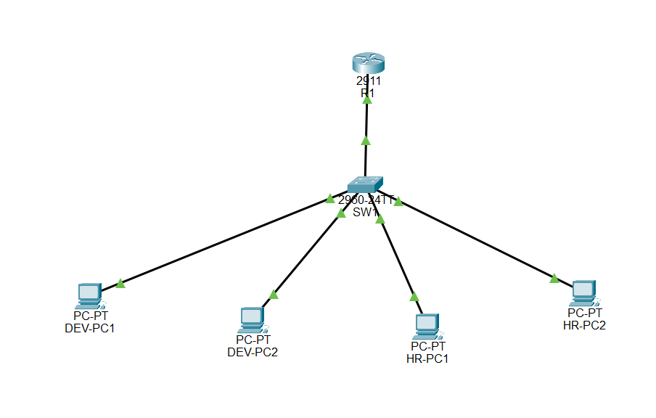Suggested device labels: R1, SW1, DEV-PC1, DEV-PC2, HR-PC1, HR-PC2.

3. Physical and Logical Connections
Using copper straight-through Ethernet connections for PC-to-switch links and the switch-to-router link. The switch-router link will later operate as an 802.1Q trunk so that traffic for both VLAN 10 and VLAN 20 can cross the single physical link.

TASK 2 — Cabling
Connect DEV-PC1 and DEV-PC2 to access ports assigned to VLAN 10, HR-PC1 and HR-PC2 to access ports assigned to VLAN 20, and connect SW1 to R1. Record the actual interfaces used.

4. VLAN Creation and Port Assignment
VLAN 10 is named DEV and VLAN 20 is named HR. The two DEV PCs are placed in VLAN 10, while the two HR PCs are placed in VLAN 20. The port connected to the router is configured as a trunk.

Example Switch Configuration
enable
configure terminal
hostname SW1
vlan 10
name DEV
exit
vlan 20
name HR
exit
interface range fastEthernet 0/1-2
switchport mode access
switchport access vlan 10
exit
interface range fastEthernet 0/3-4
switchport mode access
switchport access vlan 20
exit
interface fastEthernet 0/24
switchport mode trunk
no shutdown
exit
end
copy running-config startup-config

TASK 3 — VLAN and Switch Configuration

show vlan brief
show interfaces trunk

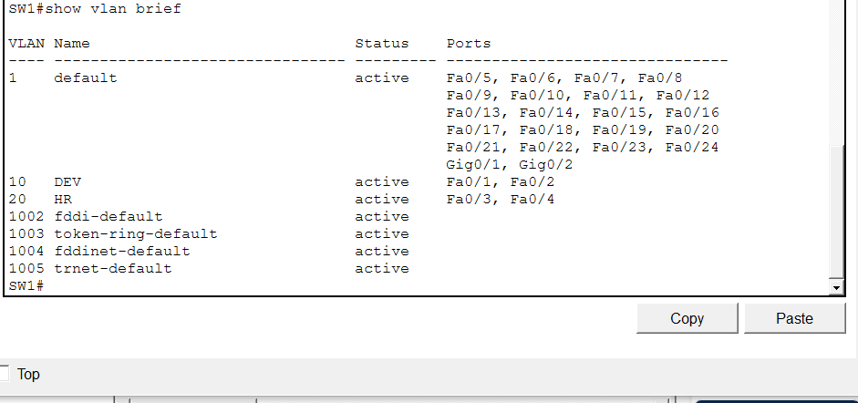

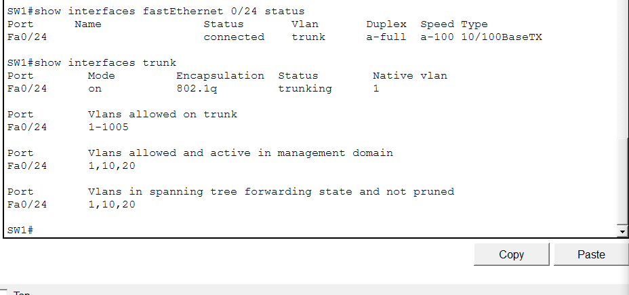

5. Router-on-a-Stick Configuration
Router-on-a-Stick uses one physical router interface divided into logical subinterfaces. Each subinterface is associated with one VLAN using 802.1Q encapsulation and acts as the default gateway for that VLAN.

Example Router Configuration
enable
configure terminal
hostname R1
interface gigabitEthernet 0/0
no shutdown
exit
interface gigabitEthernet 0/0.10
encapsulation dot1Q 10
ip address 192.168.10.1 255.255.255.0
exit
interface gigabitEthernet 0/0.20
encapsulation dot1Q 20
ip address 192.168.20.1 255.255.255.0
exit
end
copy running-config startup-config

TASK 4 — Router Configuration
Configuring the router using the interface connected to the switch. If your router uses a different interface name, use the interface actually connected to SW1. Verify the subinterfaces with show ip interface brief.
show ip interface brief

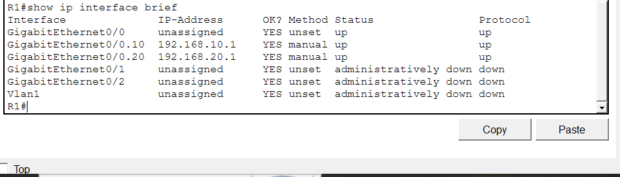

6. End-Device IP Addressing
Device | VLAN | IP Address | Subnet Mask | Default Gateway
DEV-PC1 | 10 | 192.168.10.10 | 255.255.255.0 | 192.168.10.1
DEV-PC2 | 10 | 192.168.10.11 | 255.255.255.0 | 192.168.10.1
HR-PC1 | 20 | 192.168.20.10 | 255.255.255.0 | 192.168.20.1
HR-PC2 | 20 | 192.168.20.11 | 255.255.255.0 | 192.168.20.1

TASK 5 — Configuring PC IP Addresses
For each PC, IP Configuration is performed ande entered the values from the table above.

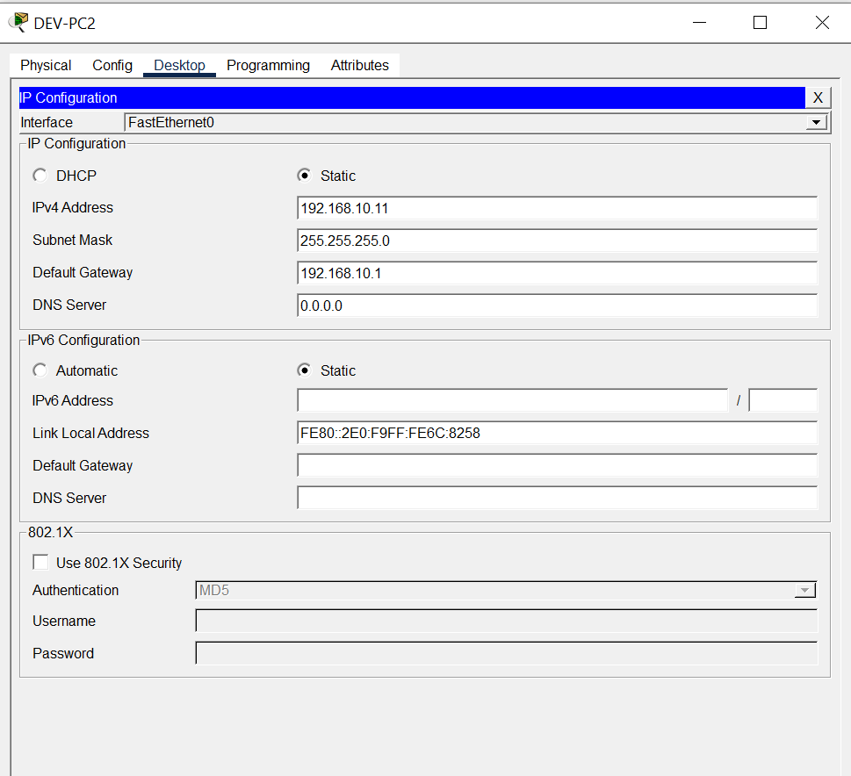

7. Connectivity Testing
The expected result is successful communication between VLAN 10 and VLAN 20 through the router. Ping tests should be performed after both VLANs, the trunk, router subinterfaces, and PC addressing have been configured.

TASK 6 — Ping Tests
From DEV-PC1, test the local gateway and an HR host:
ping 192.168.10.1
ping 192.168.20.10
From HR-PC1, test the local gateway and a DEV host:
ping 192.168.20.1
ping 192.168.10.10
Record the actual results below. A first ping may occasionally time out while ARP information is learned; confirm that subsequent packets succeed before declaring connectivity successful.
Source | Destination | Command | Actual Result
DEV-PC1 | 192.168.10.1 | ping | SUCCESS
DEV-PC1 | 192.168.20.10 | ping | SUCCESS
HR-PC1 | 192.168.20.1 | ping | SUCCESS
HR-PC1 | 192.168.10.10 | ping | SUCCESS

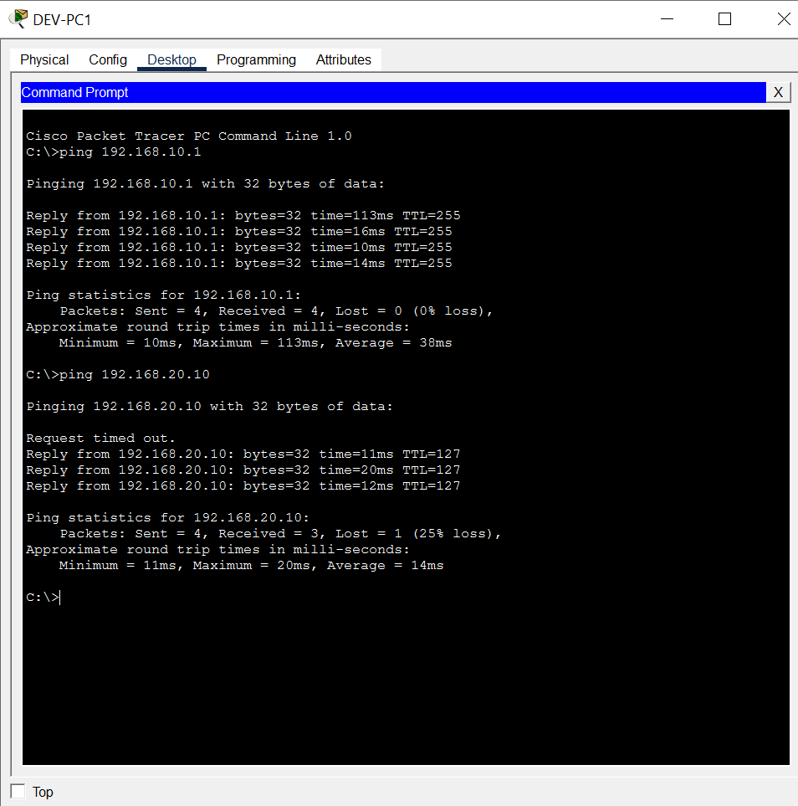

8. Verification Commands
SW1:
show vlan brief
show interfaces trunk
R1:
show ip interface brief
PCs:
ping <destination-IP>

TASK 7 — Verification Evidence
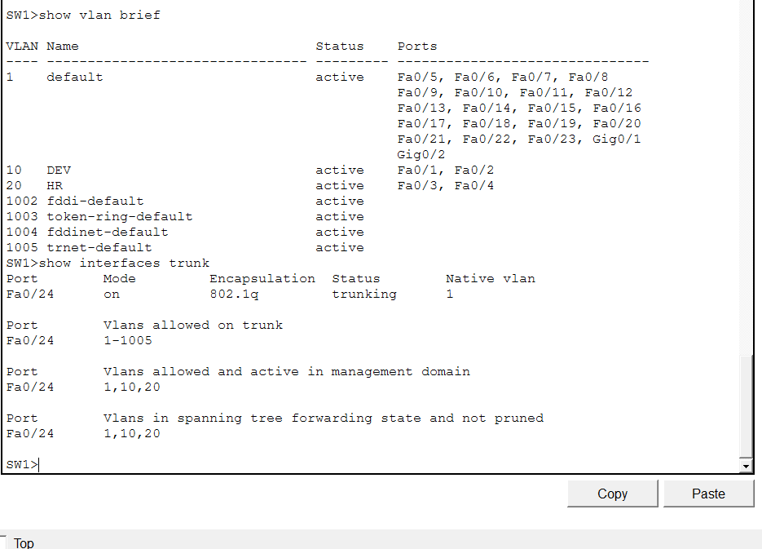

9. Results and Discussion
The completed design separates the Development and Human Resources departments into VLAN 10 and VLAN 20. The switch provides Layer-2 VLAN separation, while the router's 802.1Q subinterfaces provide Layer-3 gateways for the two networks. The trunk carries traffic from both VLANs between the switch and router. Successful ping tests between a DEV host and an HR host demonstrate inter-VLAN communication through the router.

10. Conclusion
This laboratory demonstrated Inter-VLAN Routing using the Router-on-a-Stick approach. VLAN 10 was used for Development and VLAN 20 for Human Resources. The switch was configured with access ports for the respective departments and a trunk toward the router. Router subinterfaces provided the default gateways for both networks. After assigning appropriate IP addresses and gateways to the PCs, connectivity between the two VLANs was verified using ping tests.

